# Business Requirements Document

Automated Loan Approval – Digital Lending Platform

*Version* *0.1*

This BRD outlines the functional and non-functional requirements for implementing an automated loan approval system within ABC Fintech’s digital lending platform to improve loan processing speed, reduce manual efforts, and enhance customer experience.

**Prepared by**

Vidisha Dixit

07/08/2025

# Table of Contents

Table of Contents …………………………………………………………………………………………………………………………….2

Introduction…………………………………………………………………………………………………………………………………….3

Document Purpose…………………………………………………………………………………………………………….3

Project Background…………………………………………………………………………………………………………….3

Purpose of Business Requirements……………………………………………………………………………………..4

Requirements Scope………………………………………………………………………………………………………………………...4

Business Problem…………………………………………………………………………………………………………………4

Proposed Plan……………………………………………………………………………………………………………………...4

BPMN…………………………………………………………………………………………………………………………………..5

Use Case Diagram………………………………………………………………………………………………………………..6

Data Flow Diagram………………………………………………………………………………………………………………7

Out of Scope…………………………………………………………………………………………………………………………7

Success Matrix………………………………………………………………………………………………………………………………….7

Key Stakeholders……………………………………………………………………………………………………………………………….7

Key Functional and Non-functional Requirements…………………………………………………………………………….7

Functional Requirements………………………………………………………………………………………………………7

Non-functional Requirements……………………………………………………………………………………………….6

Data Requirements……………………………………………………………………………………………………………………………6

Security Requirements………………………………………………………………………………………………………………………6

Interface Requirements…………………………………………………………………………………………………………………….7

Possible Constraints………………………………………………………………………………………………………………………….8

Assumptions…………………………………………………………………………………………………………………………………….8

Project Plan and Delivery Schedule………………………………………………………………………………………………….8

Communication Plan…………………………………………………………………………………………………………………………8

Revision Log……………………………………………………………………………………………………………………………………10

Appendices…………………………………………………………………………………………………………………………………….11

Approval………………………………………………………………………………………………………………………………………….12

# Introduction

## Document Purpose

This BRD outlines the functional and non-functional requirements for implementing an automated loan approval system within ABC Fintech’s digital lending platform to improve loan processing speed, reduce manual efforts, and enhance customer experience.

## Project Background

**ABC Fintech**, a digital lending platform, has served customers for the past 10 years with digital solutions to their financial needs on the go. ABC Fintech aims to stay competitive in the rapidly evolving digital lending space by replacing legacy manual underwriting with an AI-assisted, rule-based automated approval system.

**The Core Features of the ABC Fintech Company**:

**1. Digital Lending**

1. Loan application & onboarding
2. KYC & identity verification
3. Credit scoring & risk profiling
4. Automated loan underwriting
5. Instant loan approval/disbursal
6. EMI scheduling and repayments
7. Loan restructuring and closure
8. Collections management
9. Fraud detection & risk analytics

**2. Payments & Wallets**

1. UPI integration (India context)
2. P2P payments and transfers
3. QR code payments
4. Bill payments (utility, phone recharge)
5. Virtual cards issue
6. Wallet top-up & balance tracking
7. Merchant payments & invoicing
8. Payment gateway APIs for merchants
9. Transaction history & receipts
10. Chargeback handling

**3. Wealth Management / Robo-Advisory**

1. Mutual funds & SIP investment
2. Stocks trading (via brokerage APIs)
3. Goal-based investment planning
4. Portfolio tracking and rebalancing
5. Risk profiling & investment suggestions
6. Tax harvesting
7. Market insights & notifications

**4. Savings & Neo banking**

1. Digital savings accounts
2. Debit card issuance & management
3. Account aggregation (via Account Aggregator framework)
4. Auto-save / round-up savings rules
5. Spending insights & analytics
6. Budgeting tools
7. FD/RD booking
8. Customer onboarding (video KYC)

**5. InsurTech**

1. Insurance comparison & selection
2. Personalized policy recommendations
3. Policy issuance & document management
4. Claims processing & tracking
5. Premium reminders
6. Embedded insurance with other services (e.g., with a loan or travel)

**6. Analytics & Risk Management**

1. Customer segmentation
2. Credit risk modeling
3. Income/expense analysis from bank statements
4. Fraud detection & real-time alerts
5. Regulatory reporting (RBI, SEBI, IRDAI, etc.)
6. Transaction monitoring (AML/CFT)

**7. Core Platform Capabilities**

1. API gateway & integration layer
2. Customer onboarding engine
3. CRM and support ticketing
4. Consent management & data privacy (GDPR/DPDP compliance)
5. Notification engine (SMS, Email, Push)
6. Audit logs & activity tracking
7. Role-based access control (RBAC)
8. Cloud-native, scalable architecture

**8. Advanced Capabilities**

1. AI/ML Models: for credit scoring, fraud detection, churn prediction
2. Chatbots/Voice Assistants: for customer queries
3. Blockchain/Smart Contracts: for decentralized finance (DeFi), KYC, or cross-border settlements
4. BNPL (Buy Now Pay Later): for consumer financing
5. Embedded Finance: integrating financial services into non-financial apps (e.g., loans in e-commerce)

## Purpose of the Business Requirements

Business requirements for major enhancements to an existing application

Business requirements for new application development

Business requirements for replacement of existing application development

Business requirements for request for proposals (RFP)

# Requirements Scope

## Business Problem

Currently, the platform suffers from long manual approval cycles, inconsistent credit decisioning, and high operational costs. Additionally, customers have reported poor experience with the legacy loan processing system.

## Proposed Solution

This project proposes the development and deployment of an **automated loan approval** engine that leverages **rule-based logic** and **credit bureau integrations** to **streamline the loan lifecycle**, **reduce manual intervention,** and **drastically cut down turnaround time.**

## BPMN

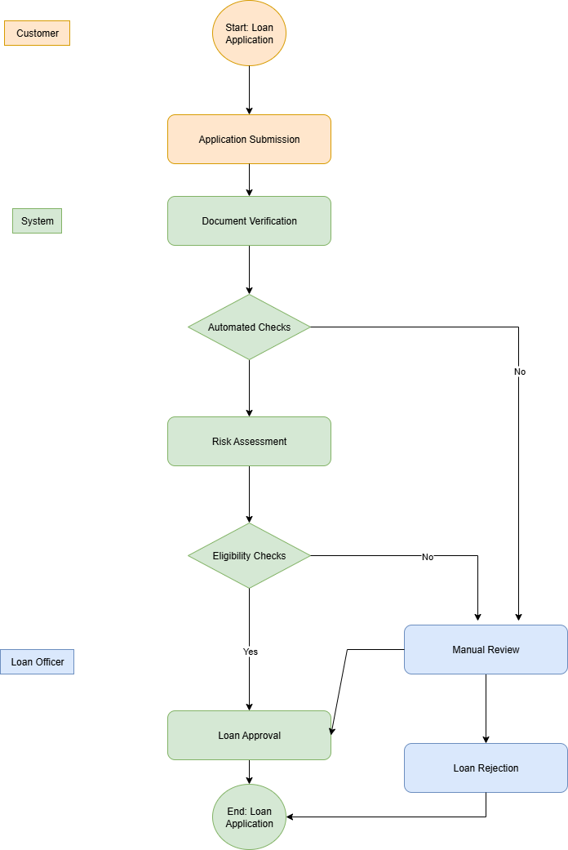

## Use Case Diagram

## Data Flow Diagram

## Out of Scope

This project does not include merchant lending, BNPL, or cross-border credit processing.

# Success Matrix

1. 90% of new customers complete loan application digitally.
2. 60% reduction in manual processing workload within 6 months.
3. Reduce TAT (Turnaround Time) for loan approval to < 5 minutes
4. Increase straight-through processing (STP) rate to 80%+
5. Improve customer acquisition via frictionless onboarding
6. Maintain default rate below benchmark threshold (e.g., < 2%)

# Key Stakeholders

1. Loan Applicants / Borrowers (Customers)
2. Credit Underwriting Team
3. Loan Officers / Relationship Managers
4. Compliance & Risk Team
5. IT & Operations Team
6. Third-Party Vendors (Credit Bureaus, KYC, Payment Gateway)

# Key Functional and Non-functional Requirements

## Functional Requirements:

1. **Loan Application**
2. Digital onboarding (web/mobile)
3. Loan type & amount selection
4. Dynamic form filling
5. Uploading documents (KYC, income proof, etc.)
6. **KYC & Identity Verification**
7. eKYC via Aadhaar/PAN (India context)
8. Facial recognition / document OCR
9. Integration with UIDAI or other third-party KYC vendors
10. **Credit Assessment**
11. Credit score retrieval (via Experian, CIBIL, etc.)
12. Bank statement analysis (via APIs like Perfios/FinBox)
13. Risk profiling using income, liabilities, and spending
14. **Automated Loan Approval**
15. Rule-based engine for eligibility & creditworthiness
16. Decision trees or scoring models
17. Instant approve/reject/flag for manual review
18. SLA: approval within seconds or minutes
19. **Loan Offer Generation**
20. Personalized loan offers
21. Auto-calculated EMI plans
22. Digital acceptance of terms and e-signature
23. **Loan Disbursal**
24. Integration with bank APIs or payment gateways
25. Disbursement tracking & notification
26. **Repayment & EMI Tracking**
27. EMI calendar setup
28. Auto-debit setup (NACH, UPI, cards)
29. Reminder alerts & payment tracking
30. **Dashboards & Reporting**
31. Admin dashboards for approval trends, delays, NPA risks
32. Borrower dashboard for application tracking
33. **Compliance & Security**
34. Audit trails
35. Regulatory reporting (RBI, etc.)
36. Secure data handling (encryption, consent management)
37. **Exception Handling or Manual Review Cases**

If risk score is inconclusive or fraud flags are raised, the system should route the application to a manual review queue.

## Non-functional requirements:

1. System response time expectations (e.g., loan approval decisions within 3–5 seconds)
2. Uptime/availability SLAs (e.g., 99.9%)
3. Scalability expectations (e.g., able to process 10,000 applications/day during peak periods)
4. Mobile-first UX
5. Role-based access control
6. API-driven architecture
7. Data privacy compliance (e.g., GDPR, DPDP)

# Data Requirements

1. **Customer Data**: Name, DOB, Contact details, Address, ID proofs (PAN, Aadhaar), Employment details, Income proof.
2. **Loan Data**: Loan amount, tenure, interest rate, repayment schedule, outstanding balance.
3. **KYC Data**: Government-issued IDs, facial recognition data, Digi Locker docs.
4. **Credit Data**: Credit score, bureau reference, risk assessment results.
5. **Transaction Data**: Loan disbursal records, repayment history, EMI schedules.
6. **Audit Data**: Timestamps, user activities, approval/rejection logs.
7. **Storage Rules**: All data must be encrypted at rest and in transit, with defined retention policies (e.g., 7 years per RBI guidelines).

# Security Requirements

1. **Authentication & Authorization:**
   * Multi-factor authentication for users and officers.
   * Role-based access control (RBAC).
2. **Data Encryption:**
   * AES-256 encryption at rest, TLS 1.3 for data in transit.
3. **Fraud Prevention:**
   * AI-based anomaly detection (suspicious patterns in applications).
4. **Compliance:**
   * Must comply with RBI, GDPR, DPDP Act.
5. **Audit Trails:**
   * Immutable logs of all user and system activities.
6. **Backup & Recovery:**
   * Daily backups with 99.9% SLA, disaster recovery plan in place.

# Interface Requirements

1. **Customer Interfaces:**
   * Mobile App (iOS, Android)
   * Web Portal (loan application, status tracking, repayment)
2. **Loan Officer Interfaces:**
   * Dashboard for manual reviews, risk insights, and disbursal tracking.
3. **System Interfaces (APIs):**
   * Credit Bureau APIs (CIBIL, Experian, etc.)
   * eKYC APIs (UIDAI, DigiLocker)
   * Payment Gateway APIs (UPI, NACH, Cards)
   * Notification APIs (SMS, Email, Push).
4. **Admin Interfaces:**
   * Compliance reporting dashboards.
   * Audit and monitoring console.

# Possible Constraints

1. Regulatory constraints (RBI/SEBI norms)
2. Integration delays with third parties
3. Data quality from applicants
4. Need for fallback in case of automation failure
5. Data bias risks in automated decisions
6. Customer digital literacy levels (especially for mobile-first use)

# Assumptions

Credit bureaus and bank APIs are assumed to be accessible and stable during implementation.

# Project Plan and Delivery Schedule (High-Level)

| **Phase** | **Timeline (Weeks)** | **Deliverables** |
| --- | --- | --- |
| Requirement Gathering | Week 1 – 2 | BRD approval, stakeholder sign-off |
| Design & Architecture | Week 3 – 5 | System design, UI wireframes, API contracts |
| Development Sprint 1 | Week 6 – 8 | Loan Application + KYC module |
| Development Sprint 2 | Week 9 – 11 | Credit Assessment + Automated Approval engine |
| Development Sprint 3 | Week 12 – 14 | Loan Offer, Acceptance, Disbursal |
| Testing & UAT | Week 15 – 16 | QA, Security testing, User Acceptance Testing |
| Go-Live Preparation | Week 17 | Data migration, Production setup |
| Deployment & Launch | Week 18 | Platform live, monitoring enabled |

# Communication Plan

1. **Stakeholder Updates:**
   * Weekly sprint reviews with stakeholders (PM, Product Owner, Compliance Lead).
2. **Team Meetings:**
   * Daily stand-ups for Dev + QA + BA team.
   * Retrospectives at the end of each sprint.
3. **Status Reporting:**
   * Bi-weekly progress report shared with senior management.
4. **Escalation Matrix:**
   * Critical issues → escalated to Project Manager within 4 hours.
   * Regulatory/compliance issues → escalated immediately to Compliance Officer.
5. **Tools Used:**
   * JIRA/Confluence (task tracking & documentation)
   * Slack/MS Teams (real-time communication)
   * Email (formal updates & signoffs).

# Revision Log

|  |  |  |  |
| --- | --- | --- | --- |
| **Date** | **Version** | **Change Reference** | **Reviewed By** |
|  |  |  |  |
|  |  |  |  |
|  |  |  |  |

# Appendices

# Approval

|  |  |  |
| --- | --- | --- |
| **Prepared By** | **Signature** | **Date** |
|  |  |  |
| **Approved By** | **Signature** | **Date** |
|  |  |  |